Literature Review

Project Title: Intercranial Aneurysm detection
Name: Muhammed Rayan
College / Department: College of engineering kidangoor, CSE
Date: October 05, 2025

Reviewed Paper:
Bo, Z.-H., Qiao, H., Tian, C., et al. (2021). *Toward human intervention-free clinical diagnosis of intracranial aneurysm via deep neural network*. **Patterns, 2(2), 100197.**
DOI: https://doi.org/10.1016/j.patter.2020.100197

1. Introduction
Intracranial aneurysm (IA) is a life-threatening cerebrovascular condition where early detection and accurate segmentation are critical for clinical diagnosis and treatment. Recent advances in deep learning and medical image analysis have enabled the development of automated systems that can support radiologists in detecting and segmenting aneurysms from CTA or MRA scans with improved speed and accuracy.

2. Bibliographic Details
Bo, Z.-H., Qiao, H., Tian, C., Guo, Y., Li, W., Liang, T., Li, D., Liao, D., Zeng, X., Mei, L., Shi, T., Wu, B., Huang, C., Liu, L., Jin, C., Guo, Q., Yong, J.-H., Xu, F., Zhang, T., Wang, R., & Dai, Q. (2021). Toward human intervention-free clinical diagnosis of intracranial aneurysm via deep neural network. Patterns, 2(2), 100197. https://doi.org/10.1016/j.patter.2020.100197

3. Problem Statement
Diagnosis of IAs from CTA images is time-consuming and error-prone. Small aneurysms are difficult to detect manually, and existing automatic segmentation methods require extensive pre- and post-processing. Additionally, most models are trained on limited datasets, making them less robust across different scanning environments.

4. Dataset Used
The study utilized a large multi-institutional dataset consisting of 1,338 CTA scans collected from six different hospitals. External datasets were also used to validate model generalization. Table 1 summarizes dataset statistics including number of cases, aneurysm distribution, and patient demographics.
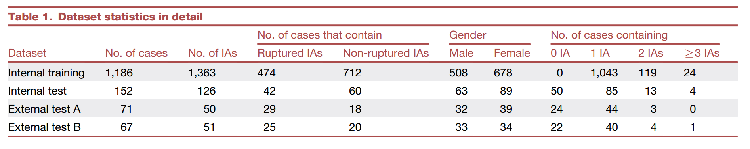
Figure 1: Dataset statistics table (Bo et al., 2021).

5. Methods & Algorithms
The authors proposed GLIA-Net (Global Localization-based Intracranial Aneurysm Network), a deep learning model that integrates a global positioning network and a local segmentation network. The global network learns spatial risk distributions from entire 3D scans, while the local network, based on 3D U-Net with residual blocks, performs fine-grained segmentation. A combination of global classification loss, local Dice + cross-entropy loss, and pyramid-weighted loss was used for training.

6. Results & Findings
GLIA-Net achieved superior segmentation performance compared to U-Net and HeadXNet across internal and external datasets. It demonstrated a Dice coefficient of 57.9% internally, with strong generalization on external datasets. Clinically, GLIA-Net significantly improved radiologists' diagnosis speed and sensitivity.
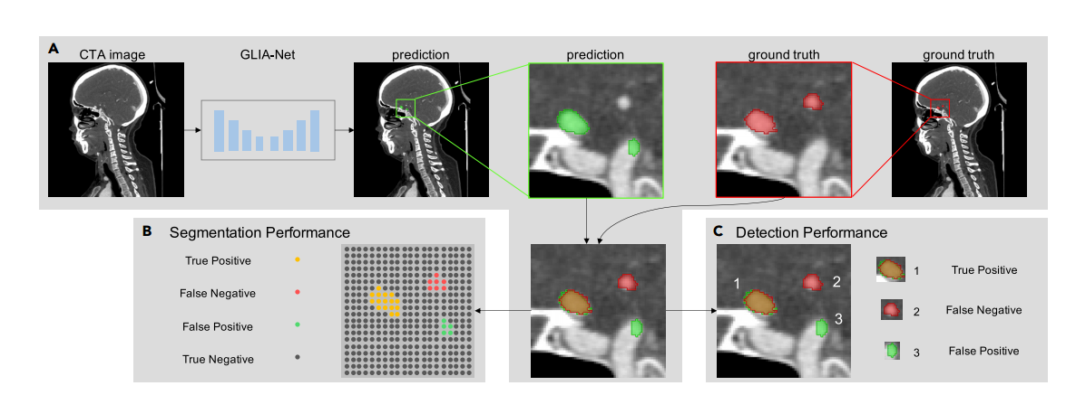
Figure 2: GLIA-Net architecture and performance evaluation (Bo et al., 2021).
GLIA-Net Performance Summary
The table below summarizes the performance of GLIA-Net (Bo et al., 2021) on internal and external test sets:
Dataset | DSC (%) ↑ | Recall (%) ↑ | Precision (%) ↑ | FP/case ↓
Internal Test | 57.9 | 82.1 | 70.4 | 4.38
External Test A | 55.7 | 79.1 | 68.3 | 4.64
External Test B | 53.1 | 77.2 | 64.5 | 5.15
Note: ↑ indicates higher values are better; ↓ indicates lower values are better.

7. Strengths and Limitations
Strengths:
- Large multi-center dataset improves model generalization.
- No manual preprocessing is required.
- Clinical validation demonstrates real-world applicability.
Limitations:
- Only CTA data was used; not validated on MRA/DSA.
- Slight performance drop on external datasets with different resolutions.
- Does not address aneurysm rupture risk prediction.

8. Relevance to Project
This paper provides an excellent foundation for intracranial aneurysm detection and segmentation projects. The dataset, architecture, and evaluation strategy can be adapted for further research. In particular, GLIA-Net demonstrates how combining global and local context can improve segmentation of small, complex vascular structures.

9. References
Bo, Z.-H., Qiao, H., Tian, C., et al. (2021). Toward human intervention-free clinical diagnosis of intracranial aneurysm via deep neural network. Patterns, 2(2), 100197.
Park, A., et al. (2019). Deep learning-assisted diagnosis of cerebral aneurysms using HeadXNet. JAMA Network Open, 2(6):e195600.
Ronneberger, O., Fischer, P., & Brox, T. (2015). U-Net: Convolutional networks for biomedical image segmentation.

